DELEGATED DECISION REPORT

Application Reference Number | 15NP0022
Description / Site Address | Replacement Conservatory at 2 Elishaw Moor  Otterburn  Northumberland  NE19 1JH
Applicant | Mr SKILBECK
Agent | Pennine Windows
Expiry date of publicity / consultations | 21 May 2015
Last date for decision | 19 June 2015

Details of the Proposal

Planning permission is sought for the construction of a replacement conservatory to the property at 2 Elishaw Moor, Otterburn.

The application property is a semi-detached dormer bungalow, considerably extended at first floor level under planning permission 13NP0024 in order to provide additional accommodation within the roofspace. The property is constructed of brick with a slate tiled roof, benefitting from a front porch and existing side conservatory, which is to be removed. The properties lie perpendicular to the A68 north west of Otterburn, set within modest curtilages surrounded by vegetation.

The extension proposes a projection from the side of the dwelling of 4m for a depth of 4.5m. This proposes eaves and ridge heights of 2.6m and 3.6m respectively, increasing to 4m in total height when measured from the rear due to relative ground levels.

Planning Policy

National Planning Policy Framework

Core Planning Principles
Chapter 7: Requiring Good Design

Northumberland National Park Core Strategy and Development Plan Policies

Policy 1: Delivering Sustainable Development
Policy 3: General Development Principles
Policy 17: Biodiversity and Geodiversity
Policy 19: Tranquillity
Policy 20: Landscape Quality and Character

Relevant Planning History

04NP0038 - Construction of conservatory and relocation of garage. Approved with conditions

13NP0024 - Extension to ground floor kitchen area and extension of first floor accommodation to include ensuite bathroom and create additional dormer window. Approved with conditions

Consultations/Representations

Rochester Parish Council: No response received.

NNPA Landscape and Forestry Officer: No objections. The proposed materials are not in keeping with those found in the Park, however are not necessarily out of keeping with the host and adjoining buildings. The proposed work would not have a significant impact upon the surrounding landscape character due to the screening effect of existing trees and vegetation. Further comments provided regarding trees and external lighting.

NNPA Ecologist: No objections or comments.

NNPA Access and Recreation Officer: No objections. The proposals are unlikely to impact upon existing public access within the area.

NNPA Historic Environment Officer: No response received.

NCC Development Management - West Area: No response received.

Public Consultation – No comments from neighbouring properties or as a result of the site notice displayed on 28.04.2015.

Assessment

The main issues to be taken into consideration in the assessment of this application are:-

- Principle of Development
- Design and Amenity
- Landscape and Visual Impacts
- Impact upon Ecology and Biodiversity
- Tranquillity
- Rights of Way

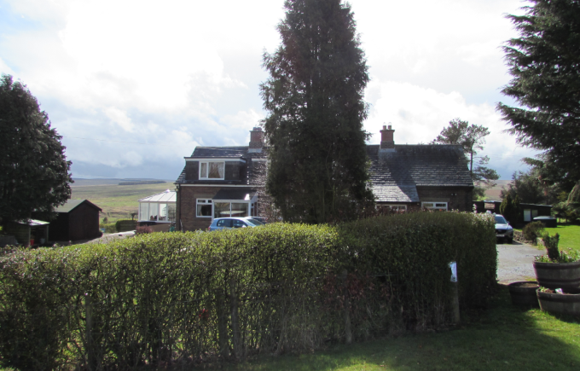
Front elevation of application site and adjoining dwelling, as seen from road verge adjacent to A68. Existing conservatory is visible to the left hand elevation of the pair of properties.

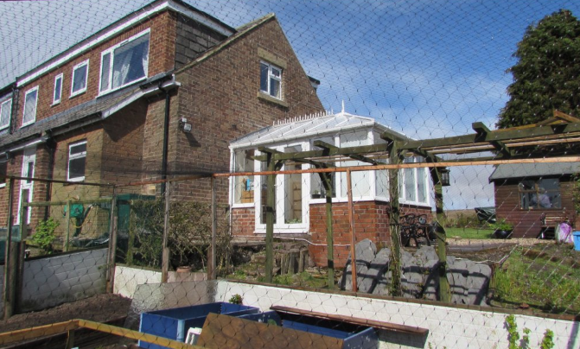
Side and rear elevations of application site with existing conservatory to side elevation, as seen from rear garden. Division between dwellings visible by change in colour of rear dormer windows along boundary line, to top left of photograph (orange and grey).

Principle of Development

The National Planning Policy Framework makes clear that a presumption in favour of sustainable development is at the heart of decision making. Policy 1 of the NNPA Core Strategy Local Development Framework seeks to ensure that development proposals will conserve or enhance the special qualities of the National Park, demonstrating high quality design and sustainable construction.

The proposal is not considered to adversely impact upon the special qualities of the Park due to its small scale and inherent nature as a replacement structure, albeit slightly larger than the existing conservatory, to an existing dwelling. The proposed extension would additionally make efficient use of land at the site, and thus is considered to meet the criteria set out in Policy 1 and the NPPF.

Design and Amenity

Core Strategy Policy 3 promotes the principles of sustainable development, requiring sustainable design and construction in order to conserve and enhance the special qualities of the National Park.

The host property is a relatively modest dwelling, extended at first floor level by virtue of dormer windows to both the front and rear elevations in order to create a dormer bungalow style property. The property additionally benefits from a front porch, existing side conservatory and slim rear kitchen extension. The property is semi-detached, with the adjoining neighbour (1 Elishaw Moor) similarly hosting dormer windows, front porch and also small outbuildings. The properties maintain a close relationship, sharing driveway access directly from the A68, with gardens surrounding on all sides. Both dwellings are constructed from red brick and slate, with modern uPVC windows.

The extension would be in keeping with the appearance of its host through using matching materials and overall building form, utilising a straight gable end, thus mimicking the design and style of its host. Whilst essentially suburban in character, the design of proposed conservatory is considered appropriate for that of the site, matching the character of the modern dwellinghouse, additionally replicating that of the existing extension. Whilst not normally encouraged, the use of UPVC is considered appropriate when contextualised alongside the existing UPVC windows at the property. The design of the proposed extension would not detract from the character and appearance of the host or adjoining property.

Given the general location of the property, impact upon residential amenity is considered to be restricted to the property immediately adjacent (1 Elishaw Moor). Due to the location of the proposed extension to the southern side elevation, there would be no impact in terms of overlooking, loss of privacy, light, or overshadowing. The proposed extension is therefore considered acceptable in terms of impact upon residential amenity. As such, in consideration of the above, the proposed extension is considered to accord with Core Strategy Policy 3.

Landscape and Visual Impacts

From a landscape perspective, the nearest publically available receptor site of the proposed development is the A68, to the north east. The proposed development would be partially visible from the highway when travelling in both directions; however views from this point would be broken up by existing conifer trees and privet hedging, and would be of no significant further impact than the existing conservatory structure. Considering the small scale, nature, design and proposed use of materials to match the existing dwellinghouses, it is not considered that the proposed extension would significantly impact upon the landscape character or views of this part of the National Park. NNPA’s Landscape and Forestry Officer has raised no objections to the proposal, which is thus considered to accord with Policy 20 of the Local Development Framework and the NPPF.

Impact upon Ecology and Biodiversity

The NNPA Ecologist has responded with no objections and no further comments on this proposal. The proposal therefore accords with Policy 17 in this respect, which seeks to protect and enhance biodiversity across the National Park.

Tranquillity

The NNPA Landscape and Forestry Officer has identified that no reference is made to any external lighting as part of the proposed development, however has advised that any new exterior lighting should be dark sky friendly. As no new lighting is proposed, it is therefore considered that the tranquillity of the Park would not be adversely affected. The proposal therefore accords with Policy 19 in this respect.

Rights of Way

The proposed development is considered unlikely to impact upon existing public rights of way within the area, and thus accords with Local Development Framework Policy 3.

Recommendation & Conditions

Grant conditional permission subject to the following conditions:-

1. The development hereby permitted shall be begun before the expiration of three years from the date of this permission.

Reason: To ensure that the development is commenced within a reasonable period of time from the date of this permission and to comply with Section 91 (as amended) of the Town and Country Planning Act 1990 and Section 51 of the Planning and Compulsory Purchase Act 2004.

2. The development hereby permitted shall be carried out in accordance with the following approved plans, documents and correspondence:

Application form received 20th April 2015
Proposed site plan received 24th April 2015
Proposed elevations received 20th April 2015
Design and Access Statement received 20th April 2015

Reason: For the avoidance of doubt, to enable the Local Planning Authority to adequately control the development and to conform with Policies 1, 3, 17, 19 and 20 of the Northumberland National Park Authority Core Strategy & Development Policies Document (Core Strategy) and the National Planning Policy Framework (NPPF).

3. The facing materials and finishes to be used in the construction of the development shall be in accordance with details contained in the application. The development shall not be constructed other than with these approved materials.

Reason: In the interests of the satisfactory appearance of the development upon completion and to conform with Policies 1 and 3 of the Northumberland National Park Authority Core Strategy & Development Policies Document (Core Strategy) and the National Planning Policy Framework (NPPF).

Informatives

1. The proposed development lies within an area that has been defined by The Coal Authority as containing potential hazards arising from former coal mining activity. These hazards can include: mine entries (shafts and adits); shallow coal workings; geological features (fissures and break lines); mine gas and previous surface mining sites. Although such hazards are seldom readily visible, they can often be present and problems can occur in the future, particularly as a result of development taking place.

It is recommended that information outlining how the former mining activities affect the proposed development, along with any mitigation measures required (for example the need for gas protection measures within the foundations), be submitted alongside any subsequent application for Building Regulations approval (if relevant). Your attention is drawn to The Coal Authority Policy in relation to new development and mine entries available at:
https://www.gov.uk/government/publications/building-on-or-within-the-influencing-distance-of-mine-entries

Any intrusive activities which disturb or enter any coal seams, coal mine workings or coal mine entries (shafts and adits) requires a Coal Authority Permit. Such activities could include site investigation boreholes, digging of foundations, piling activities, other ground works and any subsequent treatment of coal mine workings and coal mine entries for ground stability purposes. Failure to obtain a Coal Authority Permit for such activities is trespass, with the potential for court action.

Property specific summary information on past, current and future coal mining activity can be obtained from: www.groundstability.com

If any of the coal mining features are unexpectedly encountered during development, this should be reported immediately to The Coal Authority on 0345 762 6848. Further information is available on The Coal Authority website at:
www.gov.uk/government/organisations/the-coal-authority

2. This planning permission is granted in strict accordance with the approved plans. It should be noted however that:
(a) Any variation from the approved plans following commencement of development, irrespective of the degree of variation, will constitute unauthorized development and may be liable to enforcement action.
(b) You or your agent or any other person responsible for implementing this permission should inform the Northumberland National Park Authority's Development Management team immediately of any variation from the approved plans and ask to be advised as to the best method to resolve the matter. Most proposals for variation to the approved plans will require the submission of a new application.

3. This Planning Application is granted subject to conditions and it is the owner and the person responsible for the implementation of the development who will be fully responsible for their compliance throughout the development and beyond. If there is a condition that requires work to be approved prior to the commencement this is called a ‘condition precedent’. The following should be noted with regards to conditions precedent:

- if a condition precedent is not complied with, the whole of the development will be unauthorized and you may be liable to enforcement action.

- In addition if a condition precedent is breached, the development is unauthorized and the only way to rectify the development is the submission of a new application. If any other type of condition is breached then you will be liable to a breach of condition notice.

 | Signature | Date

Planning Officer

Head of Development Management or Chief Executive

