DELEGATED DECISION REPORT

Application Reference Number | 15NP0078
Description / Site Address | Construction of new farmhouse, walled garden and plant room/garden building, demolition of existing cottages and conversion of 'threshing barn' situated within steading buildings to form 2no. holiday/tourism units with parking and a farm office at Thompson Walls, Kilham, Mindrum, Northumberland, TD12 4QT
Consultation Expiry | 22 October 2015
Last date for decision | 24 November 2015

Details of Proposal/Site

This proposal is for the demolition of existing cottages, the construction of a new replacement farmhouse (with an outbuilding and boundary walls to the rear) and the conversion of a threshing barn and attached building into a pair of holiday lets. The site is in a remote location close to the northern boundary of the National Park, to the south-west of Kilham.

This application seeks to demolish existing single storey cottages at Thompson Walls, as part of the proposal. The applicant’s supporting statement explains that the existing cottages are split into two residences. The existing cottages are located to the north-west of the existing road and public right of way that runs through Thompson Walls Farm.

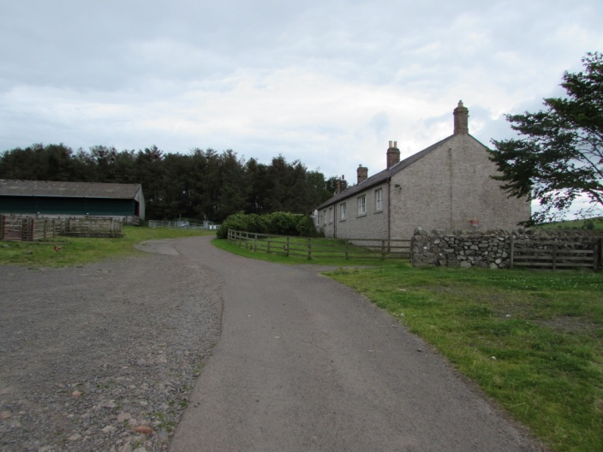
Existing Cottages at Thompson Walls (right of shot), viewed from the access road to the east (2015)

The proposal is to replace the existing cottages with a new two-storey farmhouse building. This building would host one larger two-storey dwelling with five bedrooms. The new farmhouse dwelling would be located to the north-west of the existing, with the mid-point of the existing and proposed dwellings around 25 to 30 metres apart.

A substantial boundary wall would also be constructed to the rear of the proposed dwelling, with the east north-eastern boundary wall also forming one side of an outbuilding that is proposed to house a biomass boiler. A lean-to greenhouse is also proposed within the proposed boundary wall. To the north-east of the property, this would be visible as a 3 metre high wall and would be located approximately 18 metres from the existing cattle building. The wall would also follow the entirety of the south and south-eastern boundary of the site, but would be largely hidden from view along most of its length due to the topography of the land, rising less than a metre above along most of this boundary.

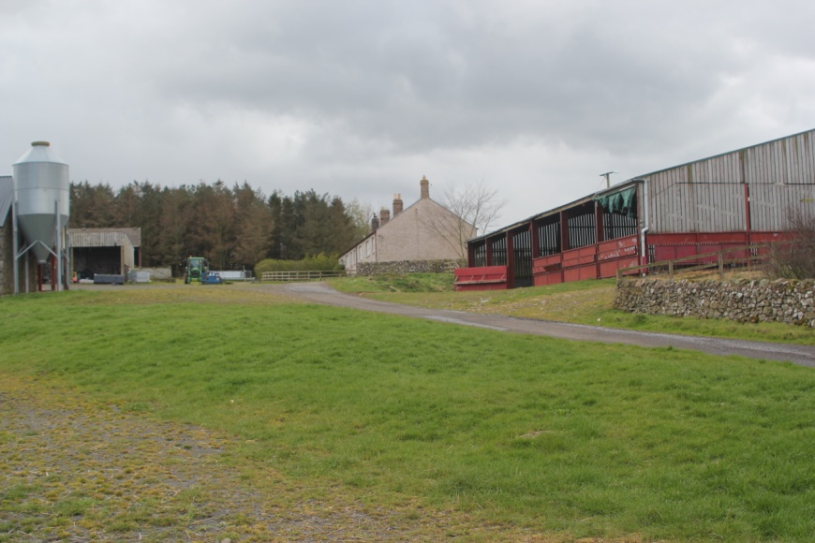
Additional view from the east (2012)

The proposal is very similar to the one proposed in a previous application under reference number 12NP0026. This earlier proposal was granted a planning consent which is now considered to have lapsed, although there have been some minor design changes to the farmhouse proposed in this scheme. The grant of this earlier permission is a material planning consideration; however the development is a new proposal and must also be determined in the context of the current development plan and other material considerations.

The proposal also involves the conversion of an existing threshing barn to the south-east of the cottages, at the opposite side of the access road. The building would be converted from agricultural use into 2no. two bedroom residential units, which are proposed to be used as holiday lettings. This conversion would also result in a number of changes to the exterior of the buildings. This includes the construction of a pitched slate roof on the building which can be seen in the centre of the photo below and timber boarding to allow the creation of a farm workshop and office at ground floor level, which has already been carried out. The physical changes appear to be identical to those proposed in the previous application 12NP0026.

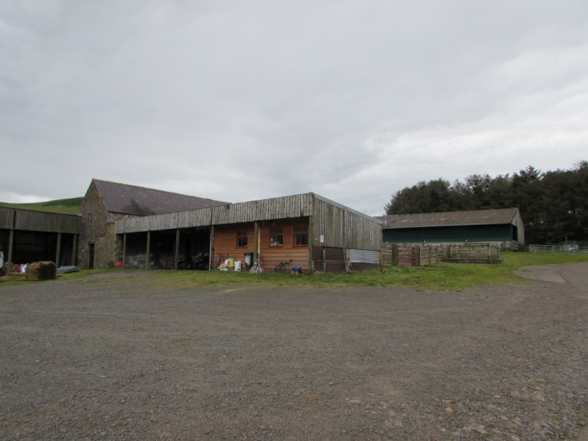
Existing Threshing Barn at Thompson Walls (2015)

The application also initially proposed the inclusion of ten large whinstone block pillars, adjacent to the road to Thompson’s Walls, to the north-east of Thompson Walls Farm. However, following discussions with the agent, these have been removed from the proposal.

Relevant Planning Policy & Guidance

- NNPA Core Strategy and Development Policies Document (Core Strategy)

Policy 1 Delivering Sustainable Development
Policy 2 Climate Change
Policy 3 General Development Principles
Policy 5 General Location of New Development
Policy 7 Conversion of Buildings outside Settlements
Policy 9 Managing Housing Supply
Policy 10 New Housing Development
Policy 12 Transport and Accessibility
Policy 14 A Sustainable Local Economy
Policy 15 Sustainable Tourism & Recreation Development
Policy 17 Biodiversity and Geodiversity
Policy 18 Cultural Heritage
Policy 19 Tranquillity
Policy 20 Landscape Quality and Character
Policy 21 Farming
Policy 25 Renewable Energy and Energy Efficiency
Policy 27 Water and Flood Risk

- NNPA Landscape SPD
- NNPA Building Design Guide SPD
- National Planning Policy Framework (NPPF)
- Planning Practice Guidance (PPG)

Relevant Planning History

15NP0053 - Variation of conditions 7 and 10 of planning permission 12NP0026 (Withdrawn)

15NP0051 - Approval of details reserved by conditions 1, 2, 3, 4, 6, 8, and 14 of planning permission 12NP0026 (Withdrawn)

12NP0026 - Demolition of existing cottages, replacing with new farmhouse and outbuilding, conversion of barn and adjoining single-storey building to form 2 no. holiday accommodation units and a farm office (Approved with conditions)

11NP0007 - Demolition of existing single-storey dwelling and construction of 3-storey detached dwelling house providing bed and breakfast accommodation (Withdrawn)

10NP0033 - Demolition of existing single-storey dwelling and construction of 3-storey detached dwelling house providing bed and breakfast accommodation (Refused)

Consultations & Representations

Northumbrian Water: No comments to make

NNPA Access & Recreation: No objection, providing that the adjacent Public Right of Way is protected throughout development.

NCC Highways: No objection, conditions recommended.

NNPA Historic Environment Officer: No objection.

NCC Public Protection: No objection

NNPA Ecologist: Notes that the proposal to convert the threshing barn is likely to have implications for European protected species (bats) consideration must be given to the Habitats Regulations. The response outlines the three relevant tests under the Habitats Regulations and notes that the mitigation is likely to be successful and should be included as a condition. The response also notes that the bat roost access points in the threshing barn should also be maintained.

NNPA Landscape Officer: No objection, although a reduction of the garden wall and the removal of the whinstone block pillars are requested.

The proposal is in Kilham Parish and it is understood that there is no active Parish Council in this area. Neighbouring Kirknewton Parish Council has made representations to state that they raised no objection to the proposal.

A notice was placed at the site and properties nearby were notified. No other representations were received in response.

Assessment

The key issues for consideration as part of this variation of condition application are:

- The principle of the housing and holiday accommodation;
- Design, Visual Appearance & Amenity;
- Effects on Landscape Character;
- Tranquillity;
- Historic Environment;
- Ecological Impacts;
- Highways & Rights of Way;
- Energy;
- Drainage & Water Supply;

Principle of Development

Conversion to Holiday Lets

Policy 5 states that the focus for local needs development should be within the local centres or smaller villages of the National Park. The policy does, however, allow for the re-use of buildings in the open countryside. The conversion of the threshing barn would therefore be acceptable, subject to it according with Core Strategy Policy 7. This policy states that conversions for tourism use would be supported where the building is capable of conversion, contributes to the Park’s special qualities and is sufficient in size to accommodate the use without significant alterations or extensions. It is considered that the proposed conversion to holiday lets would meet with this policy. Policies 14 and 15 of the Core Strategy and paragraph 28 of the NPPF state also weigh in favour of the proposal, as they support economic development and tourism development in rural areas.

It is necessary to include a condition restricting the occupancy to short-term holiday lets, as a permanent residential unit in this location would conflict with Policy 7 and require local needs restriction in line with Policy 10.

Replacement Dwelling

Policy 5 of the Core Strategy does allow for new buildings to be constructed in the open countryside providing that they are replacing an existing building and are not materially larger than this building. For residential units, it must also be clear that the previous use of the property to be demolished was for residential purposes. Although the proposal for the replacement dwelling is a two storey dwelling replacing existing single storey cottages, it is sited at a lower level than the existing building and therefore appears to be of a similar height. It is also of a similar footprint. Therefore, the proposed dwelling would not appear to be materially larger than the cottages that the building would replace, in this case. The proposal would accord with Core Strategy Policy 5.

Core Strategy Policy 10 requires that all new dwellings are restricted in perpetuity to those meeting a local need, as defined in the Core Strategy. The proposal involves demolishing cottages, which are understood to be two residences, replacing them with one property. As there are no additional residential properties being created, there would be no reason to impose a local need restriction on this property. The cottages do not currently have any occupancy restrictions on them.

It is necessary to include a condition requiring the demolition of the cottages once the new dwelling is brought into use, to avoid the creation of an additional dwelling, which would be contrary to Policy 5 and would require local needs restrictions in line with Policy 10.

Design, Visual Appearance & Amenity

The existing cottages have a light pink painted render, the threshing barn is a more traditional stone and slate construction, and there are a number of more modern agricultural buildings and structures on the site, reflecting no overall architectural character within this collection of buildings. Surrounding settlements, including Kilham, Longknowe, Westnewton, Coldstream and Yetholm also display a variety of building materials and styles, suggesting that there is no overall dominant building vernacular within the local area.

The proposed farmhouse would be located slightly further north of the existing cottages that are to be demolished. While the proposal is for a two storey building to replace a single storey building, it is set at a much lower level, meaning that the increase in height compared to the existing would be less than a metre higher. The proposal would not give rise to any substantial increase in the footprint of the building. The proposed farmhouse is considered to be of an appropriate scale that would sit comfortably within the cluster of building in which it lies.

A stone and slate construction is proposed of a traditional design with attractive detailing. Whinstone is considered to be appropriate in this location, as it is not a bright material and necessary to ensure that the facing materials are not too brightly coloured. The applicant has put forward a suggestion to use random whinstone, with mixed, lighter shades of whinstone which would potentially relate well with the lighter sandstone used for elements such as the quoins and cills. If such materials can be appropriately sourced, this is likely to be appropriate. A darker whinstone would potentially require a darker material to be sourced for the quoins, etc. A condition requiring further details of the materials is proposed.

A boundary wall to the rear of the farmhouse is proposed, with two small outbuildings within it. While this is a rather large wall, much of it would be screened from outside the site by surrounding land, particularly to the south. On this basis, it is not considered to be inappropriate in its scale. Proposed details of materials for this wall need to be submitted to ensure that its appearance will be appropriate in the context of its surroundings.

The conversion of the threshing barn will involve changes to the wooden post built building that adjoins it. It is considered that these changes would be in keeping with the surroundings. The slate roof that is to be added would be set well below the main ridge height of the threshing barn and would remain subservient and not unduly prominent. A condition is recommended to require that additional stone and the slate roof to be used in this part of the development match the existing stone and slate that make up the exterior of the threshing barn.

There are no other residential properties within the vicinity of the site and neighbouring residents would not be affected. A sufficient gap is maintained between the proposed holiday lets and the proposed farmhouse to ensure there would be no potential effects on the residential amenity of occupiers through overbearing or overlooking in the future.

The development is considered to accord with Core Strategy policies 1 and 3 in respect of its design, its effect on the visual appearance of the property and its immediate surroundings and due to its lack of adverse impacts on amenity. The effects of the proposal on the wider landscape character of this part of the National Park are assessed in the following section.

Effects on Landscape Character

The site currently hosts a cluster of existing farm buildings, surrounded by an open, expansive landscape. The site lies within the Cheviot Rounded Hills Character (to the north-west) and the Northern Hills, Bowmont Water and Glendale Character Areas (to the south-east). Land rises steeply to the south and falls away more gradually to the east and north.

The National Park’s Landscape Officer has commented on the proposal, and raises no objection to the demolition of the cottages and the erection of the proposed new farmhouse or the conversion of the threshing barn. This stance is accepted, as, subject to suitable materials being formally agreed, the proposed building would sit comfortably within the landscape as part of the existing cluster of buildings at Thompsons Walls. The proposed changes to the threshing barn and adjacent building would not substantially alter the appearance of the building and would not have any harmful effect on the wider landscape.

The only key public receptor point identified by the Landscape Officer is the right of way that runs through the site, which also forms the access road. It is also noted that there is access land to the south and east of the site, although this is likely to be used much less frequently than a designated right of way. Sites used by the public to the west are over 2km away and not raised as a concern by the Landscape Officer.

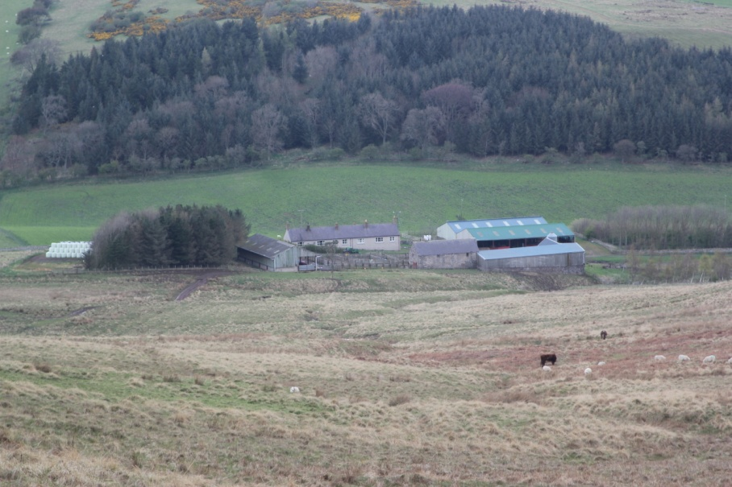
Views of the site from access land to the south (2012 - above/below)
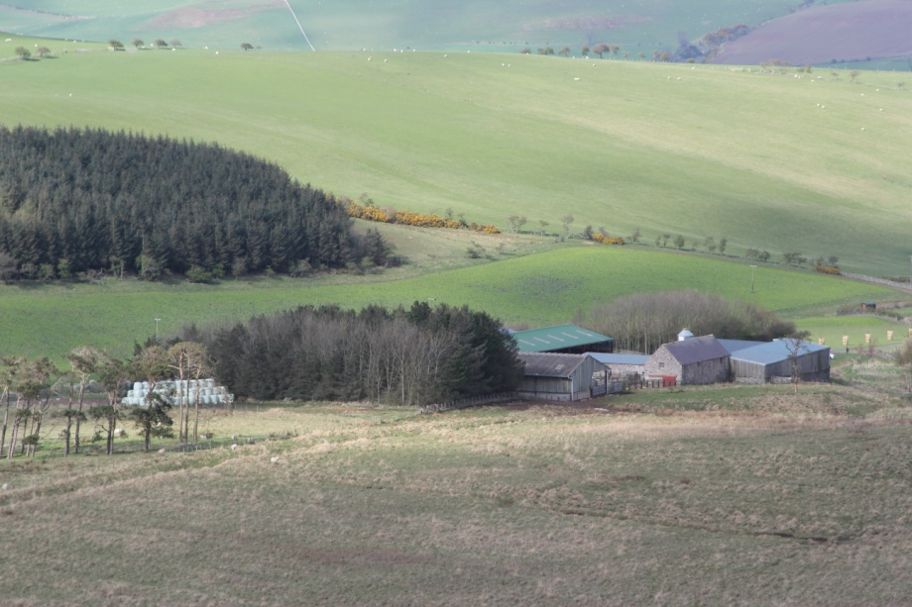

The landscape officer suggests reducing the boundary wall to 2 metres in height. While this would undoubtedly reduce its visibility to some extent, it is not considered that would be necessary in order to make the proposal be acceptable. An additional plan has also been provided with the application, which clarifies that the wall would not be visible as a 3 metre high wall. It would rise only a metre or so above the surrounding grounds levels to the immediate south of the site. Where a three metre wall was visible to the east, it would be only be prominent in very immediate views, as it would be well screened in most views from the east along the access road, by the large cattle’s building that sits around 18 metres away from the proposed wall.

The Landscape Officer has also sought the provision of additional landscaping. On balance it is considered that the amount of landscaping proposed to the south-west and north-east of the proposed dwelling is sufficient to add character to and soften the appearance of the development, particularly considering the level of visibility of the development from public viewpoints and existing tree screening in and around the site.

It is considered that the ten whinstone blocks proposed as part of the application would be inappropriate and an incongruous feature in the context of the surrounding open landscape and would affect wider views across the landscape. This is accepted by the Landscape Officer, who feels these would be visually prominent features, particularly when viewed from the public right of way that also forms the access road to the site. These have now been removed from the proposal following discussions with the applicant.

Tranquillity

The main potential for the tranquillity of the National Park to be affected would be through external lighting. The nature and scale of the proposal is unlikely to lead to any other threat to the tranquillity of the area.

External lighting is not proposed in the details that have been submitted, however a condition is recommended for inclusion within any grant of planning permission, to allow the effects of external lighting on the National Park and International Dark Sky Park area to be managed, in accordance with Core Strategy policies 1 and 19 and paragraph 125 of the NPPF.

Historic Environment

The Historic Environment Officer has provided a response summarising relevant entries within the Historic Environment Record. There are two entries, including the cottages that are proposed to be demolished. The Historic Environment Officer believes there would be no justification for retaining these buildings on the grounds of historic or architectural interest. The deserted medieval village of Antechester is also referred to in the Historic Environment Record, although there is no evidence for this within the application boundary. There is little potential for archaeological deposits relating to this to be harmed by the proposals.

There are no other known heritage assets in the vicinity of the site that would be affected by the proposal. The proposal accords with Core Strategy policies 1 and 18 and Chapter 11 of the NPPF.

Ecological Impacts

It is noted that the planning application is likely to have implications for European protected species (bats), as a small bat roost in the threshing barn is likely to be impacted upon by the proposals. Due consideration is therefore given to the Conservation of Habitats and Species Regulations 2010.

The National Park’s Ecologist has assessed the ecological implications of the proposal. The response outlines the three relevant tests under the Habitats Regulations and notes that the mitigation is likely to be successful and should be included as a condition. This means that the proposal would not be considered to be detrimental to the maintenance of the favourable conservation status of the species in its natural range (the third test).

The Ecologist’s response also makes reference to the other two tests, that the proposal would be required for reasons of overriding public interest and that there must be no satisfactory alternative to the proposal.

Natural England’s guidance states that the overriding interest would include meeting a specific need including those of an economic and social nature, including employment and housing development. The Ecologist’s advice is that the first test would ordinarily be met where the proposal accords with adopted planning policies, as this would demonstrate that the development is in the public interest. Whilst this does not in itself demonstrate an overriding public interest, it is a positive indication in assessing this. Natural England guidance states that in granting a protected species licence it would need to be demonstrated that there was a genuine need or purpose. The conversion of the building to holiday accommodation would have a genuine purpose and internal works would be necessary to facilitate this.

There are no reasonable alternatives that would better accommodate the development at this site, when assessed against development plan policies and other material considerations. The remaining two tests are therefore met.

Guidance from Natural England states that the greater the impacts of the proposal on protected species, the more evidence that these tests are met would be required. Guidance also states that a proportionate approach should be adopted by LPAs in assessing this. As the impacts relate to a single, small roost, affecting low numbers of a common species of bat, and the application includes mitigation that is likely to be successful, and in taking a proportionate approach, it is considered that these two tests are met.

The Ecologist has also stated that the demolition of the cottages is unlikely to impact on bats.

Subject to the mitigation being implemented (which can be achieved through a planning condition), it is considered that the proposal will accord with Core Strategy policies 1 and 17, the NPPF and the provisions of the Habitats Regulations.

Highways & Rights of Way

The Highway Authority has assessed the proposal and believes that the proposal will not have an adverse impact on the safety of users of the highway in the area. No objection is raised. However, the response goes on to request planning conditions.

It is understood from the content of the Highway Authority’s response that the access road which passes the property is adopted. One of the conditions relates to temporary storage off the highway (to avoid obstruction of the highway), which the applicant has already provided details of in plan 15/450/4. The highway authority has not raised any objection to these details. It is considered that a condition should be worded to allow a suitable temporary storage off the highway, but should not require the submission of further details.

The other condition requested relates to the provision of the vehicular access points in accordance with the highway authority’s specifications (to achieve access that does not cause danger or inconvenience to other road users). These conditions (10 and 11) are included (with minor amendments to the wording) to ensure that the requirements are reasonable in the context of this proposal and meet the relevant tests for planning conditions.

Subject to these conditions, the Highway Authority is satisfied that there is no threat to highway safety or convenient movement along the highway

The proposal would not affect the status of the Public Right of Way that runs along the road, or public access along it and would therefore accord with Core Strategy Policy 12.

Energy

The NPPF (paragraph 97) encourages LPAs to design their policies to maximise opportunities for renewable technologies in new developments. Northumberland National Park’s Core Strategy Policy 25 contains a requirement for all new development to embed renewable technologies to offset at least 10% of the energy requirements of the development when in use.

The property will have an HDG 65kW biomass boiler installed within an outbuilding to provide energy for the farmhouse. A supporting letter from an energy consultant has been provided to state that this can provide 100% of the heating requirements for the proposed buildings. A condition is proposed to ensure that this is implemented before the residential or holiday let units are first brought into use.

Policy 25 also seeks to minimise the amount of energy used during construction and maximise energy efficiency through factors including the orientation and insulation of developments. The conversion of existing buildings to create the holiday lets is a positive factor. The use of locally sourced materials would be desirable in order to meet with this property. However, the priority in this case is to source locally appropriate materials that ensure the creation of an attractive development on the site that is harmonious within its surroundings.

The proposed renewable energy measures will create a substantial amount of energy, in excess of the minimum standard in Core Strategy Policy 25. It is considered that the requirements of Policy 25 and the NPPF are met.

Drainage & Water Supply

The Environment Agency is the statutory consultee advising the LPA. A proposal of this scale falls outside of the proposals that the Environment Agency wishes to be consulted on. The method of foul drainage proposed is through a new package treatment plant. Planning Practice Guidance states that this the most preferable option, other than a mains sewer connection. While information has not been provided by the applicant to demonstrate this, it is accepted that the proposal could not be connected to the mains sewer, given the remote location it is highly likely to be unfeasible for the proposal to be connected to the mains sewer. NNPA’s records show that the nearest mains sewer within the National Park would be in Alwinton. The proposed foul drainage method proposed is considered to be acceptable, in accordance with Core Strategy Policies 1, 3, 17, the NPPF and PPG.

The applicant’s supporting statement indicates that the water supply would be spring fed and currently serves the cottages and the farm for livestock, although no more specific information is provided. NCC Public Protection is the statutory consultee that advises the LPA on whether there would be any likelihood of existing and proposed consumers of a water supply being affected. No objections have been raised in the NCC Public Protection officer’s response. The small scale of the proposal and lack of immediate neighbours is also noted. It is accepted that the information provided is sufficient in the circumstances of this case and that there is no evidence to suggest that the proposal would fail to accord with Core Strategy Policy 3 in this case.

Summary

It is considered that the proposal will deliver sustainable development in accordance with the development plan and the NPPF, while also having regard to other material considerations. A number of conditions are necessary to ensure that sustainable development will be achieved, which are set out below.

Recommendation

It is recommended that planning permission is granted, subject to the following conditions:

1. The development hereby permitted shall be begun before the expiration of three years from the date of this permission.

Reason: To ensure that the development is commenced within a reasonable period of time from the date of this permission and to comply with Section 91 (as amended) of the Town and Country Planning Act 1990 and Section 51 of the Planning and Compulsory Purchase Act 2004.

2. The development hereby permitted shall be carried out in accordance with the following approved plans, documents and correspondence:

- Application Form received on 15/09/15
- Location Plan15/450/01 received on 12/11/15
- Site Plan15/450/02 received on 12/11/15
- Survey Data 15/450/03 received on 15/09/15
- Compound Storage, Vehicle Parking, Temporary Access 15/450/04 received on 15/09/15
- Elevations and Cross Sections 15/450/05 received on 12/11/15
- Non-mains drainage system15/450/06 received on 15/09/15
- Access details 15/450/07 received on 15/09/15
- Farmhouse Ground Floor Layout 15/450/08 received on 15/09/15
- Farmhouse First Floor Layout 15/450/09 received on 15/09/15
- Farmhouse Roof Plan15/450/10 received on 15/09/15
- South/North Elevations 15/450/11 received on 15/09/15
- West/East Elevations 15/450/12 received on 15/09/15
- Sections 15/450/13 received on 15/09/15
- Foundation Details 15/450/14 received on 15/09/15
- Garden / Plant Room Elevations /Plans15/450/15 received on 15/09/15
- Proposed Floor Plan Layout 15/450/17 received on 15/09/15
- Proposed Elevations/Sections15/450/18 received on 15/09/15
- Greenheat Renewables Letter dated 3rd September 2015 received on 15/09/15
- All About Trees, 31st August 2010, as updated by BSG Ecology Letter dated 1st September 2015, received on 15/9/15
- Design, Access & Justification Statement received on 15/09/15
- Sustainability, Design and Access Statement received on 15/09/15

Reason: For the avoidance of doubt, to enable the Local Planning Authority to adequately manage the development and to ensure the proposal accords with Policies 1, 2, 3, 5, 7, 9, 10, 12, 14, 15, 17, 18, 19, 20, 21, 25 and 27 of the Northumberland National Park Authority Core Strategy & Development Policies Document (Core Strategy) and the National Planning Policy Framework (NPPF).

3. The holiday lets hereby approved shall be occupied for holiday purposes only and shall not be occupied as a person’s sole or main place of residence. The operators shall maintain an up-to-date register of the names of all occupiers of the holiday let hereby approved and of their main home addresses and shall make this information available at all reasonable times to the Local Planning Authority.

Reason: To prevent a permanent and unrestricted residential use in a location where this would not otherwise be in accordance with adopted planning policies, namely Core Strategy policies 7 and 10.

4. The existing cottages shall be demolished in their entirety within 6 months of the proposed dwelling hereby approved being first brought into use, unless otherwise agreed in writing by the Local Planning Authority.
Reason: To ensure that the development hereby permitted does not create a separate dwelling unit in a manner that would fail to accord with Core Strategy Policies 5 and 10.

5. Prior to the commencement of the construction of the dwelling hereby approved, samples and the details of provenance of the random stone proposed in the exterior of the building, the stone to be used for the quoins, cills and other details and the slate to be used in the exterior of the roof shall be submitted to and agreed in writing by the Local Planning Authority. The development shall be constructed in accordance with the approved details.

Reason: In order to preserve and enhance the visual appearance of the area and the wider landscape character, in accordance with Core Strategy policies 1, 3 and 20 and the NPPF.

6. Prior to the commencement of the construction of the boundary wall hereby approved, samples and the details of provenance of the stone to be used in the construction of the wall shall be submitted to and approved in writing Samples boundary wall & outbuilding associated with proposed dwelling by the Local Planning Authority. The development shall be constructed in accordance with the approved details.

Reason: In order to preserve and enhance the visual appearance of the area and the wider landscape character, in accordance with Core Strategy policies 1, 3 and 20 and the NPPF.

7. The stone and slate to be used in the conversion of the buildings to holiday lets shall suitably match the stone and slate used on the exterior of the existing threshing barn, to the satisfaction of the Local Planning Authority.

Reason: In order to preserve and enhance the visual appearance of the area and the wider landscape character, in accordance with Core Strategy policies 1, 3 and 20 and the NPPF.

8. Prior to the fixing of any external lighting associated with the development, details of the external lighting shall be submitted to and agreed in writing by the Local Planning Authority. Details should include:
- The specific location of all external lighting units;
- Design of all lighting units;
- Details of beam orientation and lux levels; and
- Any proposed measures such as motion sensors and timers that will be used on lighting units.

The approved lighting scheme shall be installed in accordance with the approved details and shall be maintained as such during the operation of the development, unless removed.
Reason: In order to ensure that there is no harmful impact upon the tranquility and intrinsically dark character of the National Park through excessive light pollution, in accordance with Policies 1 and 19 of the Core Strategy and paragraph 125 of the NPPF.

9. The development shall be carried out in full accordance with the mitigation set out in Part 2 of the ‘All About Trees, 31st August 2010’ ecological report. Particular attention is drawn to the need to carry out works that could affect bats in either late September – October or late March – April, to avoid bat hibernation and maternity periods.

Reason: In order to afford adequate protection to any bats that may be present, in accordance with Core Strategy policies 1 and 17, the NPPF and the Provisions of the Habitats Regulations 2010.

10. Bat roost access shall be provided in accordance with the roost access shown on the following plans:

- Proposed Floor Plan Layout 15/450/17 received on 15/09/15
- Proposed Elevations/Sections15/450/18 received on 15/09/15

Reason: In order to afford adequate protection to any bats that may be present, in accordance with Core Strategy policies 1 and 17, the NPPF and the Provisions of the Habitats Regulations 2010.

11. Prior to commencement of the development hereby approved, provision shall be made off the highway for a temporary storage area within the site. The storage area must be sufficient to accommodate the storage of materials during the development of the site without obstructing the adjoining highway. Within three months of the completion of the development, the land shall be restored to its original condition, or in accordance with the details approved as part of this application.

Reason: To avoid obstruction of the adjoining highway and Public Right of Way in accordance with Core Strategy policies 3 and 12.

12. The vehicular accesses from the site to the county road U1017 shall be modified/constructed in accordance with Type 'A' of the Northumberland County Council standard specifications (copy enclosed), defined by granite or whinstone setts, or as otherwise agreed in writing with the Local Planning Authority. The development hereby permitted shall not be brought into use until the said accesses have been so completed.

Reason: To achieve access to and from the site in a manner which does not cause danger and inconvenience to other road users, in accordance with Core Strategy Policy 3.

13. The renewable energy measures specified in the Greenheat Renewables Letter dated 3rd September 2015, received on 15/09/15, shall be implemented in full, prior to the first occupation of the approved development and retained thereafter for the lifetime of the biomass boiler, unless otherwise agreed in writing with the local planning authority.

Reason: In order to ensure that the development incorporates adequate renewable energy technologies and energy efficiency measures to accord with Core Strategy Policy 25 and NPPF paragraph 96.

Informative Notes:

1. This planning permission is granted in strict accordance with the approved plans. It should be noted however that:

(a) Any variation from the approved plans following commencement of the development, irrespective of the degree of variation, will constitute unauthorised development and may be liable to enforcement action.

(b) You or your agent or any other person responsible for implementing this permission should inform the Local Planning Authority immediately of any proposed variation from the approved plans and ask to be advised as to the best method to resolve the matter. Most proposals for variation to the approved plans will require the submission of a new planning application.

2. This consent is granted subject to conditions and it is the owner and the person responsible for the implementation of the development who will be fully responsible for their compliance throughout the development and beyond. If there is a condition that requires work to be carried out or details to be approved prior to the commencement of the development this is called a “condition precedent”. The following should be noted with regards to conditions precedent:

(a) If a condition precedent is not complied with, the whole of the development will be unauthorised and you may be liable to enforcement action.

(b) In addition if a condition precedent is breached, the development is unauthorised and the only way to rectify the development is the submission of a new application. If any other type of condition is breached then you will be liable to a breach of condition notice.

3. Kilham footpath 5 runs for a distance of 1,800 metres from Longknowe in the north-east, following the access road though Thompsons Walls before heading south-west to terminate at the property at Elsdonburn Shank. This footpath also co-exists with the U1017 minor road from Kilham to Elsdonburn Shank. This Public Right of Way and Public Highway must be protected throughout the implementation of the proposed development and the works must have no effect on accessing these routes. No action should be undertaken to disturb the surface of the path, obstruct the path or in any way prevent or deter public use of the path without the necessary legal diversion or closure order having been made.

4. Should any bats, or evidence of bats, be found prior to or during the development, all works must stop immediately and a suitably qualified ecologist contacted for further advice before works can proceed. All contractors working on site should be made aware of the advice and provided with the contact details of a relevant qualified ecological consultant.

5. Your attention is drawn to the need to obtain a Natural England European Protected Species development licence before redevelopment of the threshing barn can commence. Natural England can be contacted on 0300 060 3900 or www.naturalengland.org.uk.

6. The Highway Authority requests that you return the enclosed form 'ACC' to Northumberland County Council relating to access works on the public highway.

 | Signature | Date

Planning Officer

Head of Development Management

Background Papers

Planning Application File 15NP0078
EIA Screening Opinion 15NP0078

