DMC2020-007 APPLICATION FOR PLANNING PERMISSION

Application No: 20NP0077

Proposed Development: Change of use of the Byre from holiday let to principal residence dwelling at The Byre Cottage, Scotchcoulthard, Haltwhistle, Northumberland, NE49 9NH

Applicant Name: Mr A Saunders

Reason for DMC Decision: The application is brought before Development Management Committee as the applicant is a Northumberland National Park Authority Member.

Recommendation: Approve with conditions

1. Introduction

  - Planning permission is sought to change the use of The Byre from a holiday let to principal residence dwelling. Planning permission was granted in 1990 for the conversion and extension of former agricultural buildings to form holiday accommodation units at Scotchcoulthard, Haltwhistle. The use of the holiday units were restricted by planning condition.

1.2 Scotchcoulthard is situated in a remote location, in excess of 1km from the nearest neighbouring residential property and approximately 4km north of Hadrian’s Wall. It is accessed via a track leading west from the minor road which runs north from Edges Green. This road turns into a gated forestry track just beyond Scotchcoulthard. The property comprises a rough ‘U’ shaped collection of buildings around a central courtyard.

1.3 In addition to the holiday units, the site also comprises the owners’ private accommodation in the main farmhouse, an annexe occupied by another family member, as well as an additional room used for Bed & Breakfast. The property also provides a games room and indoor swimming pool for use by guests.

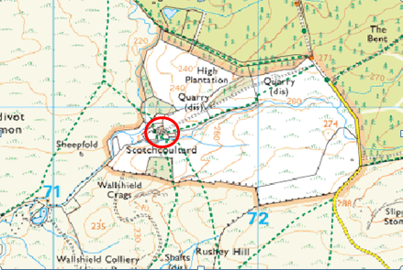
Figure 1: Scotchcoulthard in its immediate setting

1.4 As outlined above planning permission was granted in 1990 for the conversion and extension of former agricultural buildings to form four units of holiday accommodation under reference 90/E/420. As part of the grant of planning permission, all of the units were subject to a Condition (Condition 5) restricting their use to holiday accommodation only. Condition 5 reads as follows:
‘The units hereby permitted shall be used solely for holiday purposes and shall not be sold off nor let (other than for holiday purposes) separate from the adjacent dwelling known as Scotchcoulthard’.
Reason: The site is not considered appropriate for general residential purposes.

1.5 The Byre cottage had been used for holiday letting purposes for a number of years. However during late 2017 following investigations, the Authority found there to have been a breach of Condition 5 through the occupation of the holiday letting unit known as ‘The Byre’ by members of the owner’s family. An application was submitted in an attempt to regularise the situation, however it was subsequently withdrawn by the applicant due to their belief that the original planning permission did not cover what had been constructed on site and therefore the condition did not cover The Byre. In September 2018 a planning enforcement notice was served on the owners requiring the cessation of the residential use, as this use was contrary to the adopted Core Strategy policies. A subsequent appeal was submitted to the Planning Inspectorate and in October 2019 an Inspector upheld the appeal and found that the Authority was correct to serve the Notice and confirmed that the Byre did fall under the requirements of the 1990 permission. The appeal did not consider the planning merits of the enforcement notice.

1.6 The planning enforcement notice was required to be complied with by 4th October 2020, at which point the requirements of the notice should come into effect. However this planning application was received as valid on 29th September 2020. Therefore it is considered necessary to determine this planning application prior to making a decision on whether to uphold the enforcement notice. Since the enforcement notice was served a new Local Plan has been adopted, which superseded the previous Core Strategy policies.

1.7 This application proposes no physical alterations to the building and solely relates to the use of the single storey building and an allocated garden area.
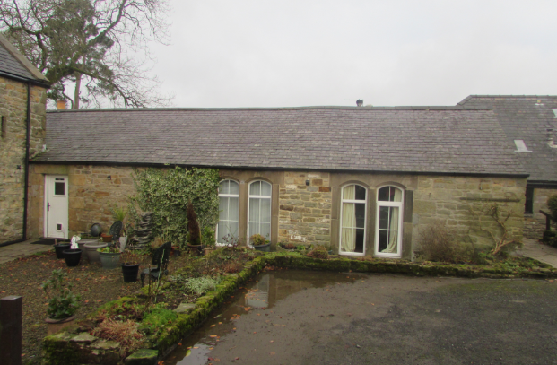
Figure 2: Front elevation of The Byre

1.8 The proposal makes provision for access to the front of the property and a small garden to serve the property, as shown on the plan below:
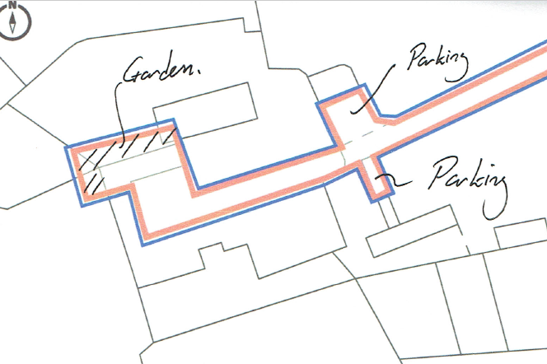
Figure 3: Red line showing proposed garden area

2. Planning Policy & Guidance

2.1 National Policies
- National Planning Policy Framework (NPPF)(2019)
- National Planning Practice Guidance

2.2 Local Policies: Northumberland National Park Local Plan (NNPLP) adopted July 2020

Northumberland National Park Local Plan

Policy ST1 Sustainable Development
Policy ST2 General Development Principles
Policy ST4 Spatial Strategy
Policy ST5 New Housing
Policy DM6 Conversion of Buildings
Policy DM7 Rural Economy and Diversification
Policy DM9 Transport and Accessibility
Policy DM10 Habitats, Biodiversity and Geodiversity
Policy DM11 Landscape, Tranquillity and Dark Night Skies
Policy DM14 Historic Landscape Assets and Built Heritage

3. Relevant Planning History

18NP0013 To vary condition 5 of planning permission reference 90/E/420 to allow ancillary residential use to either family members of the owners or employees of the business, at the Byre Cottage, Scotchcoulthard, Haltwhistle, Northumberland, NE49 9NH. Withdrawn by applicant.

11NP0025 Demolition of attached outbuildings to rear and side and construction of two- storey rear and side extension to dwelling house. Conditional Planning Permission Granted 01/07/2011

98NP0073 Conversion of outbuildings to provide kitchen area, food store and dining area Conditional Planning Permission Granted 22/01/1999.

90/E/420 Conversion and extension to former agricultural building to form four units for holiday accommodation. Conditional Planning Permission Granted 10/10/1990

4. Consultee Responses

4.1 Henshaw Parish Council: No objection

4.2 NCC Highways: No objection: subject to a condition requiring car parking to be implemented in accordance with the approved plans and informatives reminding the applicant not to store building materials or equipment or deposit mud / debris / rubbish on the highway.

4.3 Public Responses: A notice was displayed at the site on 1st October 2020. No representations have been received in response.

5. Assessment

5.1 Introduction

5.1 The key material planning considerations are:
- The principle of the development;
- Impact upon National Park special qualities;
- Design and amenity;
- Highways;
- Foul drainage

Principle of the development

Sustainable Development

5.2 The National Planning Policy Framework (NPPF) places emphasis on a presumption in favour of sustainable development to guide decision making. Policy ST1 of the Local Plan adopts a similar presumption in favour of sustainable development and defines the qualities and criteria which are deemed to represent ‘sustainable development’. The degree to which the proposals accord with these qualities is discussed throughout the report.

Principle of Development – Location of Development

5.3 Strategic Local Plan policy ST4 seeks to direct new development to a series of settlements named within the policy. As Scotchcoulthard is not located within one of the named settlements, it would be considered to fall within the open countryside. Policy ST4 goes on to detail situations where new development would be allowed in the open countryside including ‘where development reuses a building in a way that supports an economic use or meets the need for principal residence or affordable housing, and is also in accordance with Policy DM6’ and ‘where the proposal is supported by other local plan policies’. The extent to which the proposal accords with Local Plan policy DM6 is considered below.

Principle of Development – New Housing

5.4 Local Plan policy ST5 sets out the Authority’s approach to new housing in the National Park. Part 3b relates to new housing within the open countryside and allows for principal residence occupancy where a building is being converted in accordance with Policy DM6. The assessment of whether this proposal meets with the more detailed requirements of Policy DM6 is set out below.

5.5 As set out in the supporting text to Policy ST5, principal residence housing is a form of market housing controlled by a condition which ensures it can be lived in by anyone but only as their main residence. This is to ensure new housing permitted in the Park is not used as a second home. As outlined in the Local Plan, a condition would be a sufficient mechanism to ensure the occupancy of the unit is confined to a person’s sole or principal residence in perpetuity.

Principle of development – Conversion of Buildings

5.6 Local Plan policy DM6 part 2 sets out criteria that need to be assessed to determine whether the building is suitable for conversion to principal residence housing. Taking each criteria in turn for The Byre:
a) The building is an attractive stone and slate single storey unit which makes a positive contribution to the landscape and therefore its retention and continued use is considered appropriate;
b) The building has already been converted, is currently lived in and there is no proposal to carry out any physical works to the building. As such there is no requirement for a structural survey to be submitted;
c) The building accommodates sufficient living accommodation for the residential use and there are no proposals to extend it;
d) The proposal makes no changes to the physical character of the building;
e) The proposed garden area would easily be accommodated without harm to the immediate landscape setting and the proposal would use an existing car parking area;
f) The requirements of Policy DM14 are considered in the section below.

Whilst no physical works are required to enable the use of the building for principal residence housing, it is considered The Byre meets with the criteria set out in Part 2 and is suitable for re-use.

5.7 Part 3 of Policy DM6 establishes criteria for ensuring the proposed new use is compatible in nature, scale and level of activity with the surrounding locality and neighbouring buildings. Part 3c) allows for principal residence housing use of converted buildings subject to three criteria:

3c) i) The Byre is located within an existing group of buildings and includes the main farmhouse within that group. The Byre has a close visual relationship to the other buildings present. This would mean that residential use of the unit would not be out of character with its immediate setting. The designation of an area of garden close to the property would seem sensible and would be easily accommodated without harm to the landscape setting of the area.

3c) ii) Whilst the building is not redundant or disused, the applicant’s agent has provided information regarding the holiday lettings business at Scotchcoulthard and how due to its size the Byre had a relatively limited contribution to the business. The agent argues that the figures submitted show that even without the Byre available for letting, the site continues to be able to offer a range of property letting sizes and that none of these are letting at capacity or levels over and above 50%, in most cases the occupancy levels in 3 of the 4 properties are below one-third in the last financial year (2019/2020). The agent continues to explain that the most comparable sized property, Hawthorn, has stood at 32% for the last two accounting years. The agent argues that this demonstrates the level of market demand and occupancy rates do not support or necessitate the maintenance of the Byre on the basis of the economic activity that it generates and as such the use of the property for principal residence housing would be consistent with the broad objectives of the newly adopted Local Plan policy to provide permanent residential accommodation. Officers agree with this conclusion in these specific circumstances and consider the building would not be required to be redundant or disused before permitting its reuse. Furthermore, given the building has already been converted and no physical works are proposed there is no requirement for this application to also enhance its immediate setting.

c) iii) The site could be considered isolated to some degree due to its access along single track roads and minor roads, however, by reason of the building being sited within a former farm steading of several other buildings with a variety of residential and business uses, it is considered the building’s remoteness would not be a reason to refuse planning permission alone.

5.8 Adherence to Policy DM14 is referred to in Policy DM6 part f). This requires development to respect and retain the built heritage of the National Park and promote high standards of design. As outlined above, there are no proposed physical changes to the Byre and the proposal would continue an existing use of the building and as such would not conflict with any of the criteria within Policy DM14.

5.9 Having regard to the adopted Local Plan policies, the principle of the use of The Byre for principal residence use is considered acceptable and in accordance with Local Plan policies ST4, ST5, and DM6.

Impact upon National Park special qualities

5.10 Local Plan policy ST2 details the general development principles which will guide new development within the National Park. Part a) of the policy advises that development will be permitted where ‘the special qualities of the National Park will be conserved and enhanced’. Policies DM10, DM11 and DM14 provide the detailed policy framework which should guide decision making when considering the impact of development on the special qualities of the National Park i.e. biodiversity, landscape, tranquility and cultural heritage.

5.11 As this application is purely seeking approval for the change of use of an existing property from holiday accommodation to principal residence housing with no physical changes to the building proposed, it is not considered that the proposals would have any material impact on the special qualities of the National Park and there would be no conflict with the requirements of Local Plan policies ST2, DM10, DM11 and DM14.

Design and amenity

5.12 Amongst others, strategic policy ST1 is supportive of development which ‘Protects or enhances the landscape character of the National Park…’ with strategic policy ST2 requiring proposals to be of a ‘high quality design that will make a positive contribution to the National Park’s special qualities’ while also seeking to ensure that ‘The proposal will not have an unacceptable adverse impact upon the amenities of occupiers’.

5.13 As outlined above the application does not propose any new development or physical changes to The Byre, and so there would be no impact on the character of the building or its wider landscape setting. There are no neighbouring properties within close proximity that would be affected by the proposal. In addition, given the nature of the residential use, in a courtyard of other residential and holiday let buildings, it is not considered there would be any impact on the amenity of the residential occupiers, over any possible disturbance by holiday makers. Given the holiday business is within the same ownership as the applicant it is considered that this would be within the control of the applicant to ensure amenity to the occupiers of The Byre is not harmed. As such it is considered there would be no conflict with the requirements of strategic policies ST1 and ST2 in this regard.

Highways

5.14 Amongst others, policy ST2 is supportive of proposals which ‘ensures the proportionate creation of an accessible, safe and secure environment for all potential users with appropriate cycling facilities and car parking provision and without compromising highway safety, the local road network or public rights of way’.

5.15 As noted, the application is not seeking permission for any new development but rather the change of use of the Byre from holiday accommodation to principal residence housing. While officers are satisfied that use as principal residence housing rather than holiday accommodation would not result in any intensification of use of the site or demand for extra parking spaces (with the Byre having been used as housing without permission for some time), the application has been supported by a site plan which identifies dedicated parking spaces to serve the property.

5.16 Northumberland County Council as Highways Authority have been consulted on the proposals. While they have raised no objection they have requested the imposition of a condition, the first part of which requires that the development is not occupied ‘until the car parking area indicated on the approved plans, has been implemented’. However, as the Byre is already occupied and the parking area already exists, officers do not consider it reasonable or necessary to attach this element of the condition. However, the second part of the condition states ‘Thereafter, the car parking area shall be retained in accordance with the approved plans and shall not be used for any purpose other than the parking of vehicles associated with the development’. It is however considered reasonable to attach this part of the condition to ensure that sufficient dedicated parking to serve the Byre is maintained in perpetuity.

5.17 NCC Highways have also recommended that informatives are added to any permission which may be issued reminding the applicant not to store building material or equipment or deposit mud / debris / rubbish on the highway. However, as noted above, as the application is not proposing any new development, officers do not consider that the imposition of these informatives would be warranted in this instance.

Foul Drainage

5.18 One of the guiding principles for new development as detailed within Strategic policy ST2 is that proposals should ‘ensure the provision of appropriate and proportionate services and infrastructure to meet the needs of the development’. Information submitted in support of the application indicates that foul sewage is dealt with by means of a package treatment plan (PTP).

5.19 The application is seeking change of use to allow the Byre to operate as principal residence housing rather than holiday accommodation. As such, the application proposes no new development and as the original application did not place any restriction on the period of time during which the holiday units could be let out (for example no period where the property has to be vacant), officers are satisfied that there would be no intensification of use over what the existing permission allows. Officers do not therefore consider that it would be warranted to require the applicant to provide details of, or make changes to, the existing foul drainage arrangements. The proposals are therefore considered to accord with the requirements of Strategic policy ST2 in this regard.

6 Conclusion

6.1 For the reasons detailed above, officers consider that the principle of the development is acceptable. The adopted Local Plan Policies allow for the occupation of buildings within the open countryside for principal residential use, subject to a number of criteria. As set out above, this application meets with the relevant criteria.
6.2 As assessed above, as the application does not introduce any new development, with the proposals purely relating to the change of use of the Byre from holiday accommodation to principal residence housing, it is considered that no material impact on the special qualities of the National Park would arise from the proposals. Furthermore, subject to the conditions detailed below and as discussed in the report, the development is considered to be acceptable and in accordance with relevant planning policies in respect of all other material planning considerations.
6.3 In terms of the outstanding enforcement notice, the grant of the permission would mean that the notice, which requires the cessation of residential use of The Byre is no longer required or enforceable. Should Members agree with officers’ recommendation to approve, then officers would recommend no further action is taken with respect to the enforcement notice.

7 Recommendation

It is recommended that Members be minded to grant conditional permission subject to the following conditions and informatives.

Conditions

- The development hereby permitted shall be carried out in accordance with the following approved plans and documents:

- Application form received 25th September 2020;
- Location Plan, Scotchcoulthard, 1:1250, received 29th September 2020;
- Location Plan, Scotchcoulthard, 1:1250 showing garden and parking; received 29th September 2020;
- Location Plan, Scotchcoulthard, 1:1250 showing access to highway; received 29th September 2020;
- Scotchcoulthard Existing / Proposed; Floor / Block Plans @ 1:200, received 25th September 2020;
- Planning, design and access statement from Robin Wood, Ref: RW/JF, dated 22nd September 2020 received 25th September 2020;

Reason: For the avoidance of doubt, to enable the local planning authority to adequately manage the development and to ensure the proposal accords with policies ST1, ST2, ST4, ST5, DM6, DM7, DM10, DM11 and DM14 of the Northumberland National Park Local Plan and the National Planning Policy Framework (NPPF).

- The development hereby approved shall be used as principal residence housing only and not be used as a second home.

Reason: For the avoidance of doubt, to ensure the development accords with Local Plan policies ST5 and DM6.

- The car parking area shall be retained in accordance with the approved plans and shall not be used for any purpose other than the parking of vehicles associated with the development.

Reason: In the interests of highway safety, in accordance with Local Plan policy ST2 and the National Planning Policy Framework.

Informative Notes

- This planning permission is granted in strict accordance with the approved plans. It should be noted however that:

- Any variation from the approved plans following commencement of the development, irrespective of the degree of variation, may constitute unauthorised development and may be liable to enforcement action.

- You, your agent, or any other person responsible for implementing this permission should inform the Local Planning Authority immediately of any proposed variation from the approved plans and ask to be advised as to the best method to resolve the matter. Most proposals for variation to the approved plans will require the submission of a new application.

- This consent is granted subject to conditions and it is the owner and the person responsible for the implementation of the development who will be fully responsible for their compliance throughout the development and beyond. If a condition is breached then you may be liable to a breach of condition notice.

Contact Officer:
For further information contact Susannah Buylla Interim Head of Planning on 01434 611577 or e-mail: planning@nnpa.org.uk

Background Papers
Planning Application File: 20NP0077
EIA Screening Report dated 30th September 2020
