CLEARWATER E RANGE 9 PERSON SEWAGE TREATMENT SYSTEM, DISCHARGE
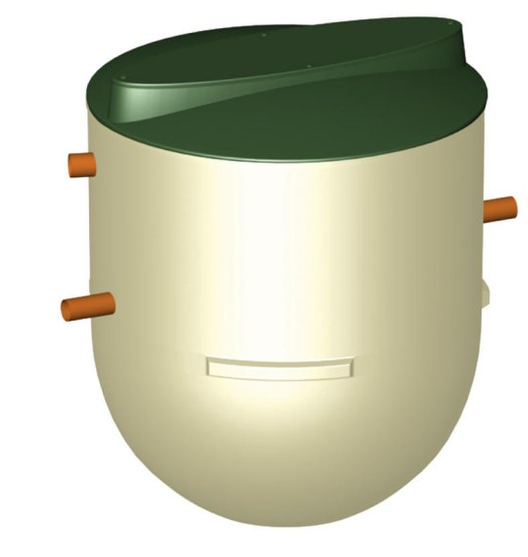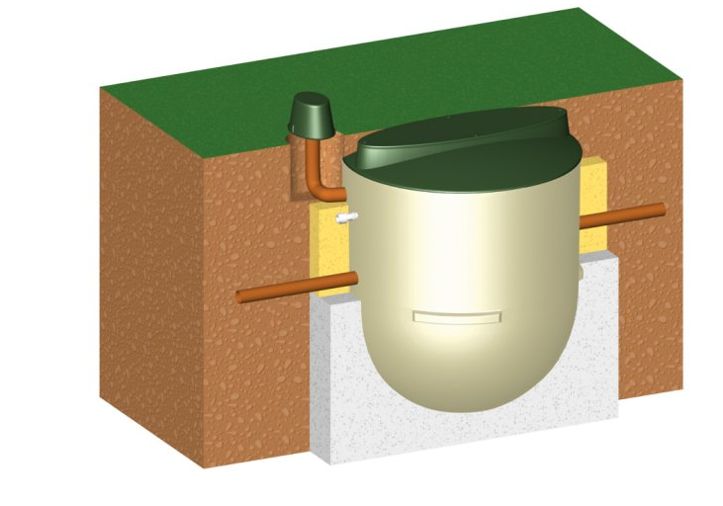

Product Description

9 Person Clearwater Sewage Treatment System
Clearwater E-Range sewage treatment system from Clearwater is fully compliant with building regulations and certified to EN 12566. Treating effluent from a domestic or commercial property to a certain level as specified and tested under European Performance Standard EN 12566. Tested for pollution removed from effluence, the power used to do this, and the level of maintenance required by this E6 sewage treatment plant, this plant is a cost-effective, low-maintenance solution for off-mains properties. The Clearwater system delivers 1200 litre capacity
Clearwater treatment plants are ideal for single houses and employ the well proven aerobic biological process for the treatment of sewage.

THREE DISTINCT PROCESS STAGES TAKE PLACE WITHIN THE SINGLE TANK:
First, coarse solids are filtered and retained for gradual breakdown. Then the resulting liquid is continuously distributed over a plastic suspended filter by an integral lift, powered by a remotely sited blower. Finally, the solids are allowed to settle and, under normal domestic conditions, treated water of 20mg/l BOD, 30mg/l S.S., 20mg/l Ammonia can be achieved.

BENEFITS:
- Superior performance rating.
- Subject to consent and site conditions, the plant can discharge directly to a watercourse.
- No mechanical or electrical components within the plant - low running and maintenance costs.
- Low level visibility with a lockable child-proof pedestrian duty cover - safe for children and pets.
- Controlled ventilation - minimises risk of odour nuisance.
- Package options to all requirements and needs.
- Easy to install and maintain with annual desludging.
Certificated to European Standard EN-12566. In 2005, a new European Performance Standard was introduced. EN-12566 requires manufacturers to submit their product to a testing regime that accurately measures the performance of treatment plants up to 50 population. These tests identify how much pollution the treatment plant removes from the sewage, what level of maintenance is required, and what power is absorbed. By holding EN-12566 certification, the Clearwater treatment plant is approved for an exemption from a permit to discharge under the new EPP2 environmental legislation.

