DESIGN & ACCESS STATEMENT :
PROPOSED BUTCHERY AT HETHPOOL, COLLEGE VALLEY.

This statement has been prepared in support of a planning application for a butchery unit at Hethpool Farm.

Reason for the proposed development:
The proposed facility is required to support the management of College Valley Estates, the applicant, and in particular the management of deer on the estate. The purpose of the building is to process pre-prepared, principally venison, carcasses from the estate, obtained through the necessary culling process and through the associated sporting business. The building will provide facilities to store carcases in a chilled environment, and to prepare and package the butchered meat for distribution. As the carcases are pre-prepared there will be no waste generated. The facility will be used by the existing Estate staff, assisted by a butcher as/when necessary.

The Site :
The preferred and application site is at Hethpool Farm at ‘entrance’ to the College Valley and within the established farm steading. There are already a range of traditional and modern farm buildings used by the Estate, and a large stoned yard which can easily accommodate the proposed building. It is also already a meeting place for estate workers and visiting stalkers and provides adequate parking.
The site withing the existing steading provides a high level of screening from public roads and most of the surrounding hillsides, both by existing buildings and semi-mature trees to the south east. The positioning of the building has been proposed to avoid any felling or lopping of adjacent trees.
The site provides easy access to the existing mains electricity and private water supplies, as well as an existing drainage system.

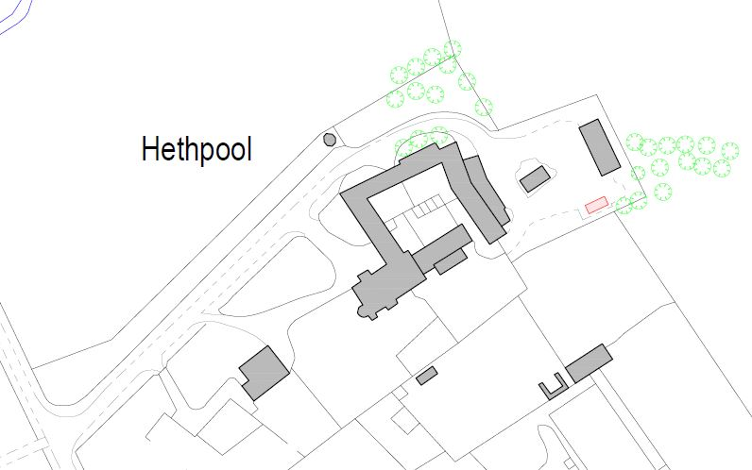

The Building :
A new pre-fabricated butchery unit is proposed rather than the adaption of an existing building as this will provide a clean environment to meet current food handling regulations.
The proposed building will be a purpose built unit by a specialist supplier, with overall dimensions of 7m x 3m x approximately 2.8m high. The building will be sited on the existing hardstand area, on concrete ground beams to provide a level base. Excavation of the existing ground will not be required. The building is constructed principally from insulated steel wall panels on a steel frame, and will be finished in RAL 12B27 Olive Green, and with timber cladding to the open collection area, which will blend with the surroundings. The roof will be a black single ply membrane, on decking, on joists with insulation. Internally the building will be finished with vinyl flooring and food-safe wall and ceiling laminate.

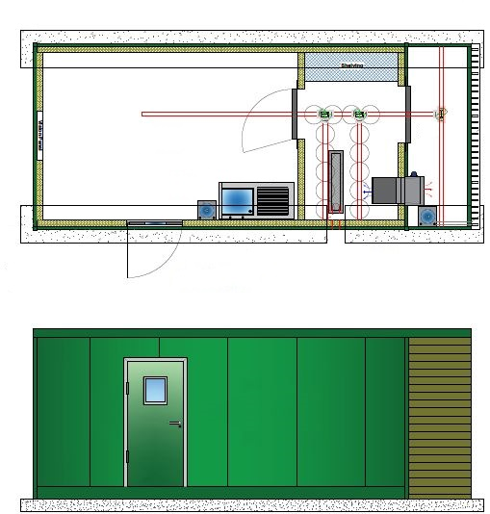

Access :
The site will be accessed via the existing farm road into the farm steading. The existing steading hardstand will provide more than adequate parking.

May 2024

